CYB 300 5-1 Lab Worksheet: Implementing a Public Key Infrastructure Lab Worksheet

Andree Salvo
Southern New Hampshire University
CYB 300-14668
Instructor: Jason Keltner

Lab: Implementing a Public Key Infrastructure

Exercise 2: Create a Self-Signed Certificate
Prompt | Response
Task 1: Take a screenshot of Step 37 showing the successful creation of the certificate file. Add your name in the command line. | 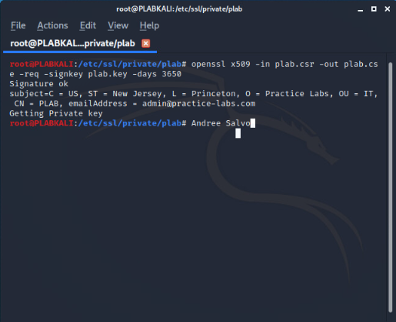

Exercise 4: Configure Certificate Revocation Lists (CRLs)
Prompt | Response
Task 1: Take a screenshot of Step 12 showing the presence of both the root CA and the subordinate CAs. Add your name in the command line. | 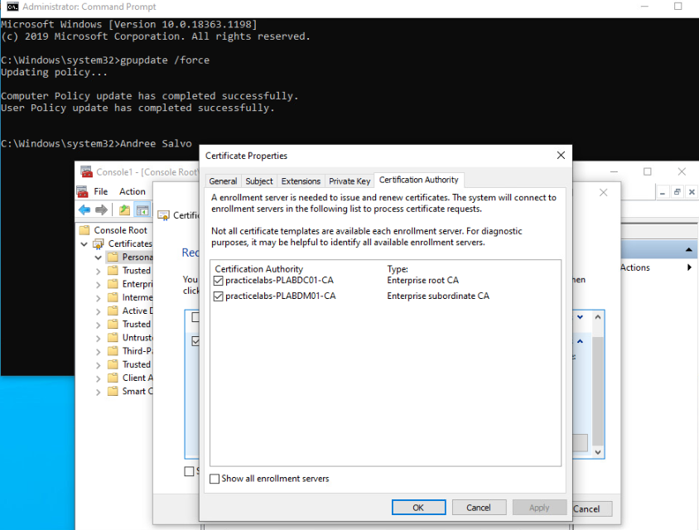
What would be the purpose of creating a subordinate certificate authority? | The purpose of creating a subordinate certificate authority is to issue certificates while keeping the root CA secure and offline.

Exercise 7: Implement Key Archival
Prompt | Response
Task 4: Take a screenshot of Step 4 showing the recovery key certificate issued to the administrator. Add your name in the command line. | 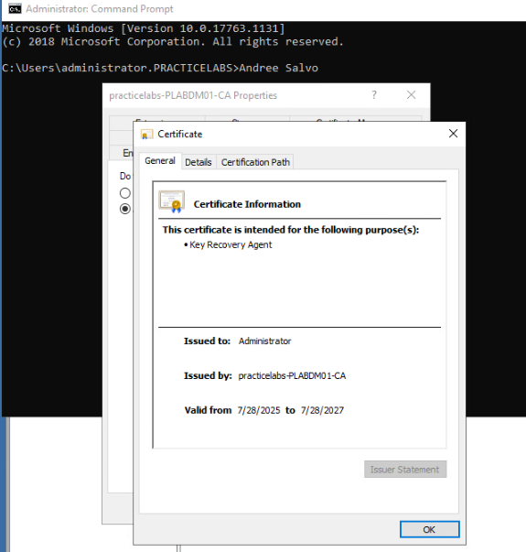
What is the importance of issuing a recovery key certificate to a restricted number of individuals? | Providing a recovery key certificate to a select few helps protect sensitive information by ensuring only highly trusted individuals have access to it, and also minimizing the risk of unauthorized exposure.

